<>cmeprojects
Proposal
Why a standalone Staff Portal, not Planner and SharePoint
Engaged Care Melbourne
Version 1.0 · November 2026
Prepared by cmeprojects

Contents

Right-click the list and choose Update field if the page numbers don't show.

Summary
Engaged Care runs its tasks, incidents, onboarding and compliance across Microsoft Planner, SharePoint lists, emails and spreadsheets. It works, but evidence is scattered, access is hard to control, and nothing reminds or escalates by itself.
We propose a standalone Staff Portal built for an NDIS provider: one place for tasks and registers, compliance with expiry dates, forms, cars, a staff phone app and a public website with an AI Assistant. It's already built and running at engagedcare-portal-beta.vercel.app.
 | Today (Planner + SharePoint) | Staff Portal
Tasks and registers | Planner boards and separate lists | One task system, a register per type, custom fields
Who sees what | Folder and list permissions, set by hand | Role-based, enforced by the database on every row
Reminders and escalation | Manual follow-up | Automatic due dates, reminders and escalation
Compliance evidence | Files in folders, expiry tracked by hand | Per person, per item, with expiry alerts and a report
Phones and shared devices | Full Microsoft sign-in | PIN-locked staff and car apps
Public website | Separate, not connected | An Assistant that answers from your own documents
Licences | A paid Microsoft licence per staff member | One subscription, any number of staff (fair use)

The problem with Planner and SharePoint
Microsoft 365 is a good office suite. Planner and SharePoint are general tools, though, and an NDIS provider needs more than a general tool for its core records.

Issues we see today
- No single record. A task in Planner, the incident in a SharePoint list and the follow-up in an email: no one place an auditor can follow.
- Permissions drift. SharePoint access is set per site, list and folder. Over time, links are shared too widely, guests stay on, and staff can see more than they should. Checking it takes a specialist.
- No row-level privacy. A list is either visible or not; you can't easily let a support worker see only their own items.
- Nothing chases itself. Due dates don't escalate, expired certificates don't alert, and overdue work relies on someone noticing.
- Weak audit trail for the NDIS Practice Standards. Version history exists, but showing who approved what, when, for a given incident is slow.
- Not built for shared phones. Staff need a full Microsoft sign-in on each device, or they stop using it.
- Licence cost per person. Every casual support worker needs a paid licence to take part.
- Reporting needs extra tools. Real reports need Power BI or exports to Excel by hand.

Is it safe?
SharePoint can be made safe, but only with careful, ongoing setup. The usual risks in small providers are sharing links set to "anyone", old staff still having access, sensitive client details in the wrong list, and no one reviewing permissions. The Staff Portal removes most of these by design: access comes from the person's role, the database itself enforces it, and turning someone off signs them out straight away.

What the Staff Portal does
- Tasks and registers: incidents, risks, maintenance, assets and general tasks, each with its own fields, due dates, helpers, approvals and escalation.
- People and roles: invites, job titles, teams, team leaders, approval of role changes.
- Compliance and onboarding (add-on): documents to read, trainings and uploads with expiry dates, and a full compliance report.
- Forms (add-on): surveys and checks, sent to staff or put in onboarding, with replies and Excel.
- Cars and the Cars app (add-on): trips, odometer, who has which car, weekly report.
- Staff app (add-on): a PIN-locked phone app with built features like Fluid intake.
- Feature builder (add-on): new registers like Fluid intake or Fridge temps without new code.
- Website and Assistant (add-on): a public website that answers questions from your documents, with call-back requests going straight to intake.
- Reports, dashboard, scoreboard, change log and system health.
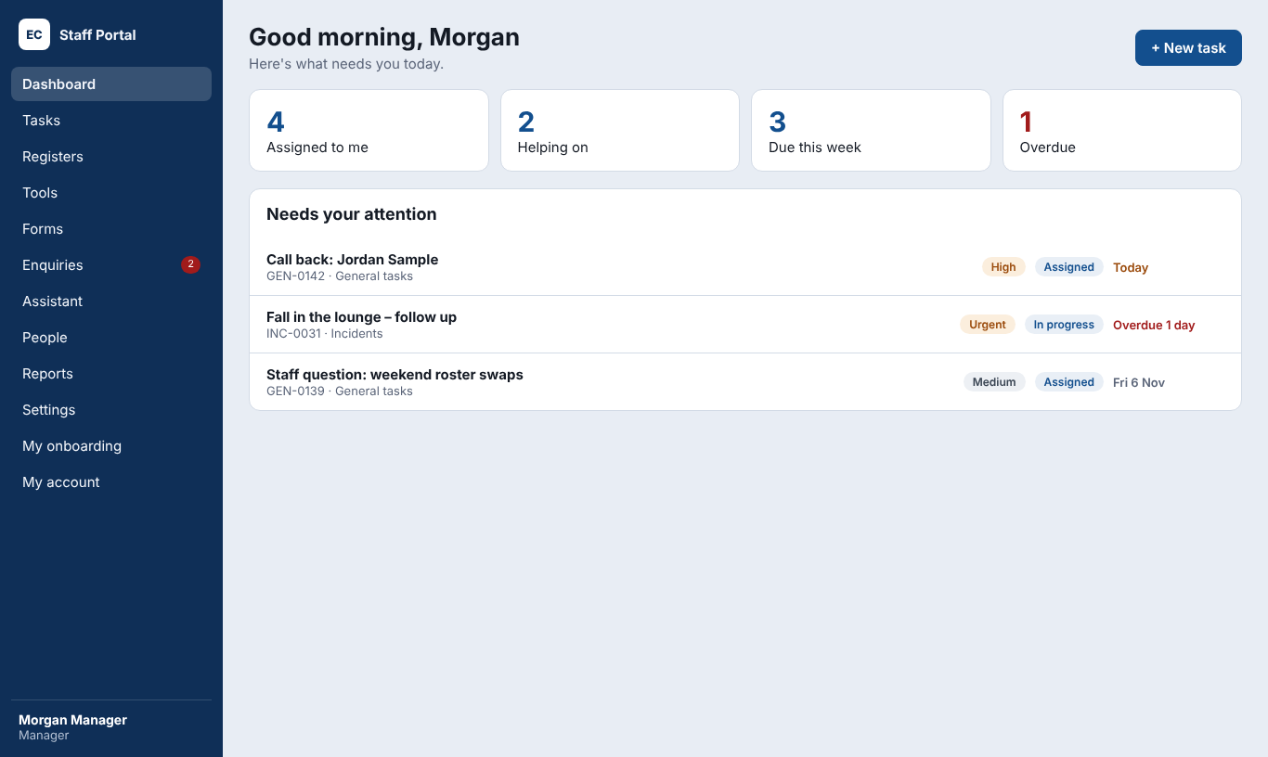
The manager's dashboard.

Why standalone
- Built around NDIS work: incidents, compliance, escalation and evidence, not generic lists.
- Safer by design: every table is protected by the database; two-factor login; a lock after 5 wrong passwords; data stored in Sydney.
- Cheaper to include everyone: casual staff don't need a Microsoft licence to use it.
- Owned and adaptable: new features in days, not a change request to a large vendor.
- Works alongside Microsoft 365: keep email, Teams and documents in Microsoft; run the operational records in the portal.

Risks and how we handle them
Risk | How it's handled
Depending on one supplier | Code in GitHub, data in your own Supabase account, restore points and documentation for any developer
Outages | Vercel and Supabase run in Sydney with high availability; System health shows problems
Data loss | Supabase Pro daily backups (7 days); undo file for every change
Staff adoption | Short training, simple wording, phone apps, quick wins first
AI answering wrongly | Answers only from your documents; a monthly spending limit; a log of questions it couldn't answer

Recommendation and next steps
- Approve the Core plan and the add-ons you need (see the Pricing document).
- Move Supabase and Vercel to their paid plans.
- Two weeks of setup and data import; staff training; go live.
- Review after 90 days.

